
Te Kura o Hau Karetu
He waka eke noa: We’re all in this waka together
32 Hillside Drive, Māoribank, UPPER HUTT 5018
Phone (04) 5269-552, 027-5269-552
Email: office@tehaukaretu.school.nz

20 February 2024

Kia ora to Whanau/families/aiga of the tamariki at Te Kura o Hau Karetu,

Wow, what fantastic kids we have here at our kura. We are having a lovely start to the year with happy kids playing in the playground and the classrooms are already humming with learning.
We are in the midst of assessments (already) and children are all giving it their best shot.


Meet the Teacher Evening - Apologies:
We had to postpone our evening to meet with the teachers as we have had lots of teachers off with illness. We have rescheduled our next Meet the Teacher to Monday 26th February from 5-6.30pm. There will be a sausage sizzle, the pool will be open, the slippery slide will be operating, and there will be a game on the field. You will get to meet your teacher, visit your child’s classroom, and meet other staff who are on site to support your child. You are welcome to bring your own picnic or fish and chips. We would love to see you there.

Kaupapa mō te wiki/Value for the week:
Akohia/Learning – we are learning how to “do our best work – strive for excellence”. This is quite tricky, because we also have to learn about perseverance. That’s when we keep going even if something is difficult. It takes lots of courage – but we know our Tamariki are up to the challenge.

Introducing Our House Captains for 2024!
We are thrilled to announce the house captains for the upcoming year, these individuals have demonstrated exceptional leadership qualities and a commitment to fostering a positive and supportive environment within our school community. Please join us in welcoming:

Tui House Weka House Kokako House Kereru House
🌟 Anne-Maree 🌟Charliee-Ellen 🌟Jensen 🌟Myla
🌟 Archer 🌟 Hasandeep 🌟Mannat 🌟Ryder
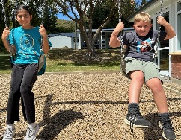
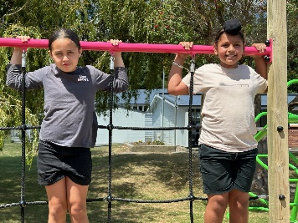
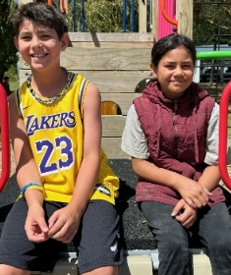
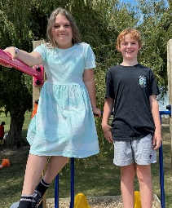

We extend our appreciation to all the students who applied for the position of house captain. While only a select few can serve as captains, each applicant has played an integral role in showcasing the qualities that make our school such a special place.

Congratulations to our newly appointed captains, and best wishes for a successful year ahead!

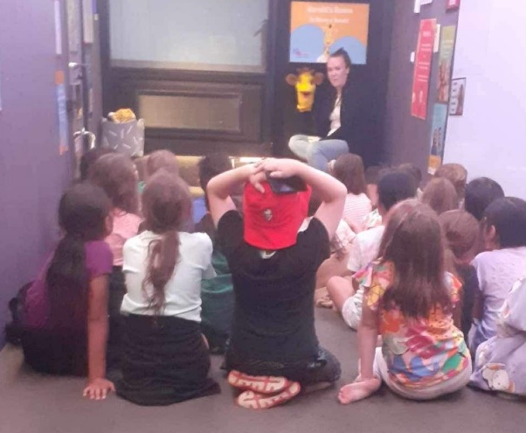
Life Education Bus:
Harold continues to be popular with our Tamariki. This week, Harold will be talking to the children about friendships, resilience and empathy. Skills we all need to take into adulthood!

Food Policy:

Our food policy states that we do not allow lollies, fizzy drink, roll ups/strings, or large bags of chippies at school. We have seen an increase in children bringing roll ups to school. Please do not give them to your child to bring to school. They have as much sugar in them as lollies, and stick to their teeth increasing the risk of cavities. They have very little nutritional value also. Maybe just give them an apple instead, which is essentially all they’re made out of anyway – apple juice! Thank you for your understanding.

Covid protocols:
Since 2020, Covid protocols have changed a lot. Just letting you know of the Ministry of Health recommendations for keeping each other safe from Covid. The advice is:
- If your child feels unwell, test for covid.
- If they test positive, they should stay at home and rest for 5 days from the first day they felt unwell.
- They are likely to continue to test positive for a while after that, but they can still return to school as long as they are feeling well.
- As the government are now not giving covid test kits away, we don’t have any Covid tests left to give you, sorry.
If your child is unwell at all, we will send them home.

Did you know? (all about importance of sleep):
- Sleep deprivation affects four key domains of wellbeing: movement, food, sleep and learning levels. Sleep provides important functions for our bodies. It’s the only time children’s bodies grow, and it allows time for our brains to organise information. It also helps us to be emotionally well and on top of everything.
- Inside your brain is the hippocampus which is the part of your brain responsible for learning and long-term memory. If your child doesn’t have enough sleep, then their hippocampus has less time to store long term memory. If a child has been deprived of sleep, then the next day they can’t recall what they’ve learned because it’s not there – it didn’t have time to process.
- When we are tired, we tend to eat more and not such good quality food. We tend to move less because we are so tired. Very active, sporty people require lots of sleep.
- When children are attached to their screens, it’s often a tricky balance between getting them off their devices and turning the lights out. Using devices is ok, but it shouldn’t be impacting on a child’s ability to sleep well. Having boundaries around device use is important. It’s not about dad taking the phone of them, but it’s about it being time to go to sleep.
- A good amount of sleep also helps us to get to school on time!
- The chart below is the recommended hours of sleep for good health. So if your child is balking at going to bed at 8pm, lights out at 8.30pm, then they should be rested with 11 hours of sleep and up at 7.30pm getting ready for school.

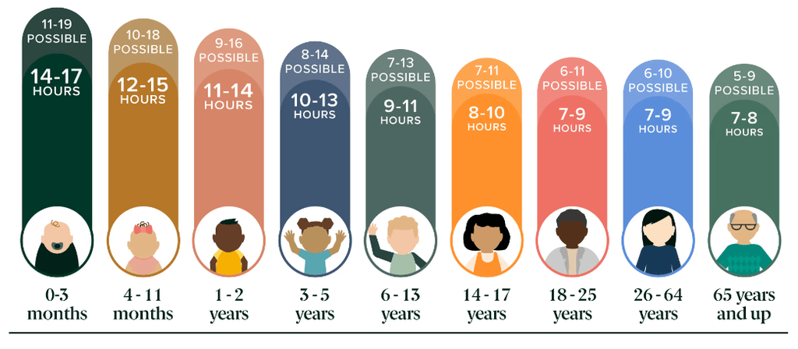

Heads up:
- Stationery: Stationery is being paid for by the school this year. If you are in Te Pūao, Te Whanganui, and Ngā Mātaamua, your child may bring a chrome book to school. This is not compulsory – we have chromebooks children can use at school.
- School Start and Finish & Attendance: Please remember that school begins at 9am and finishes at 3pm. It’s important children are at school every day and on time. However, we would rather children were at school late than not at all. Getting to school by 9am is important for children’s routines. Thank you.
- Absences: If your child is not going to be at school, please advise the office via text on 0275269552, or via the Skool Loop app. Make sure you tell us the reason they are absent.

- New Details: If you have a new address or phone number, please let Roseanne know. It’s important that we have your latest contact details in the event of an emergency.
- Potae/Sunhat: Please ensure your child has a wide brimmed sunhat to wear during terms 1 & 4.
- Swimming/kaukau: Swimming will continue until week 6. Swimming is part of the curriculum and all children are expected to participate. Togs must be polyester, not cotton. Long hair needs to be tied up. Anyone who has had vomiting or diarrhoea in the last two weeks will not be able to swim – thank you.
- Entry in to and from School: Mornings - drop your child off at the front gate or the back. Our carpark can be quite full and it’s safer to drop your child off at the gate and have them walk in. You do not need to drop them to the office unless they are running late – thank you.
End of the day –
  - Front gates are closed all day from 9am-3.10pm. We will cross children over at the end of the day. Please use the “crossing”.
  - Back gates: There will be two walking bus teachers to walk your children to the intersection of Hillside Drive, Moeraki, and Norana Roads and will be crossed over by the road patrollers.

- Breakfast Club: Runs 5 days per week from 8 – 9.30am. We require help on a Thursday & Friday. If you would like to volunteer for this job, please advise Roseanne or Rachel at the office. Thank you.
- Lunches in Schools: We provide lunches each day. The kai will be offered to every child. All children are expected to at least try the kai.
- Water only: We are a water only school which means children can only drink water while they are at school. We would encourage your child to bring a drink bottle of water each day – particularly while we are experiencing such hot temperatures. Thank you.
- Assemblies: We hold our weekly celebration Assembly on Fridays at 9am. All whanau are welcome to attend.

- School Values – we teach the ākonga/students about these values every day. It would be great if you would be able to speak with your child at the end of each day to find out what they learnt about the values:

  - Whakaute/Respect
  - Akohia/Learning
  - Kotahitanga/Togetherness
  - Atawhai/Kindness
- School Policies: Our school policies and procedures can be found at schooldocs.co.nz, username: maoribank and password waka. We would encourage you to check these out as we will ask you to have your say on their review every three years. Thank you.

Ngā mihi nui
Karen Wellington,
Kaihautu/Timekeeper on the Waka

Schedule of Events Term 1, 2024
Week 3 19-23 Feb | Life Education Trust Week – Harold is bringing his bus to school this week.
Week 4 26 Feb-1 Mar | 29th Feb – U-Day. Dress up as something with a U, wear your undies on the outside, be a Unicorn, bring an umbrella or a ukelele. Fundraising for UHUB – a community space for whanau/families in Upper Hutt to support every need for your child. We are aiming to raise $4 per child.  Support for Whanau with Children who are Neurodiverse Hui in Staffroom 9.30-10.30am.
Week 5 4-8 March
Week 6 11-15 March | I have a Dream BBQ Friday 15th after school  Swimming finishes this week.
Week 7 18-22 March | Student Conference for a selected few, Friday 22nd March
Week 8 25-29 March | Good Friday – Easter Holiday
Week 9 1-5 April | Easter Monday and Tuesday – Easter Holidays
Week 10 8-12 April | Last day of term 1 12th April. Return to school on 29th April.  9th-12th April – Dental Van/Bee Healthy Bus at school.

Whānau Contact Details
Child’s Name
Child’s Name
Child’s Name
Child’s Name
Child’s Name

Parent/ Caregivers name
Address
Address
Mobile Phone
Email Address

Parent/ Caregivers name
Address
Address
Mobile Phone
Email Address

Pamol/Panadol – I agree to staff giving my child pain relief Yes/No (please circle) You will be notified if medication is given.
Food Allergies – My child has no known food allergies. Yes/No
My child has the following food allergies; ____________________________________________________ ______________________________________________________________________________________________________________________________________________________________________________
Permission Slip
For low risk school trips, we have a blanket permission slip that we ask you to sign at the beginning of each year please. Low risk trips may include travelling on bus or in a vehicle to a local destination, a local walk, sports trips etc. Any trip that is of a higher risk – we will advise you and forward you a separate permission slip to sign e.g. camp.
I give permission for my child/ren (name)_____________________________________________________
to attend low risk trips throughout 2024. I understand the school will advise us of the trip beforehand, and that all their safety protocols will be followed.
Name of Parent/Caregiver______________________________________________________
Signature of Parent/Caregiver___________________________________________________
Date __________________________



