
Te Kura o Hau Karetu
He waka eke noa: We’re all in this waka together
32 Hillside Drive, Māoribank, UPPER HUTT 5018
Phone (04) 5269-552, 027-5269-552
Email: office@tehaukaretu.school.nz

7 May 2024

Kia ora, Talofa Lava, Mālō e lelei, Kia orana, Namaste, Kumusta,

We are celebrating our successes this week. Celebrating from last week’s assembly, we have Gaara on the left who won the Goodies or the Bag. He won a Star Wars hat just in time for “May the 4th” and a Spider Man Lego set. That smile says it all about how he feels winning that!
Nicholas, second from the left, is so proud of his picture – it’s beautiful. He worked really hard on it and spent lots of time getting it just right. Adrienne in the middle, has been at school a whole 4 days, and already she can write a whole sentence all by herself! It says, “Em is a pup.” Honestly Adrienne, we are so impressed with your writing skills – we think you are amazing! Rico and Dawn working on the same writing as Adrienne. They all know every single one of the sounds. They have all formed their letters correctly, AND they have finger spaces. That’s a lot of things to remember when you’re 5.
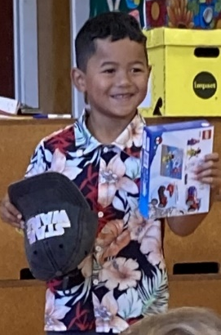
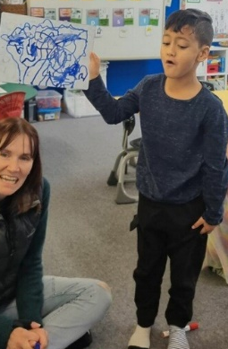
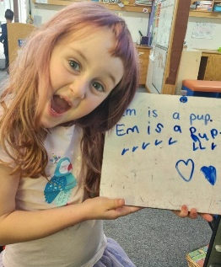
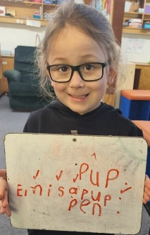
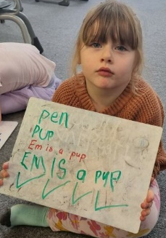

Each week at assembly, we celebrate our tamariki who show great skills in learning, values, and key competencies (these are things such as thinking skills, managing themselves, working with others etc). Look at how many of our Tamariki received Principal’s Awards at assembly last Friday! We hold assembly on Friday at 9am. All are welcome. We would love to see you there.
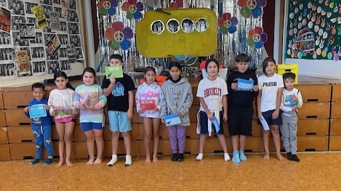
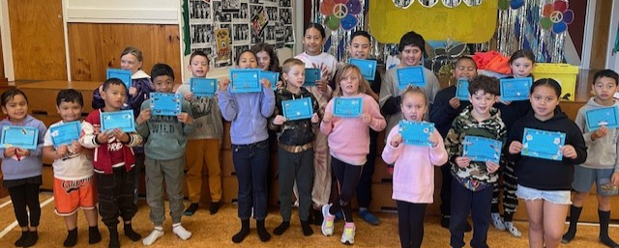

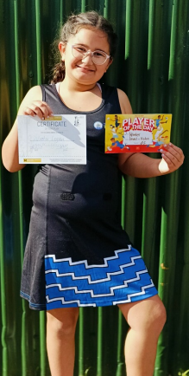
Sport:
Congratulations to Winter who won Player of the Day for her efforts at netball on Saturday. Tino pai, Winter!


Kaupapa mō te wiki/Value for the week:
Our value for this week we are learning about is Whakaute/Respect. In particular, we are learning to show respect to our Kaiawhina/Teacher Aides. Whenever a teacher aide tells us to do something, we follow their instructions first time, every time.

Cross Country:
Our School Cross Country Day is this coming Monday 13th May where the whole school will be participating in running around the block (years 1-4 once around the block, and years 5-7 twice). We would love it if you would dress up in your house colours on this day. We will be running from 12pm. Whānau/Families are welcome to join in the fun. House colours are:
- Kereru - red
- Tui - green
- Kokako - blue
- Weka - yellow
The Interschool Cross Country is on Sunday 19th May at 1pm at Harcourt Park. Anyone is welcome to participate, but you will need to confirm with Matua Shea please to get you registered for the race. Thank you.

How safe are your children online?
On Tuesday 19th May from 7-9pm at Mangaroa School, Rob Cope will be speaking to parents regarding Cyber Safety. I cannot emphasise enough important it is that you know what your child is up to online, and that you know the best ways to manage them. I have heard Rob speak, and he really helps to clarify the enormity of the issues our kids are coping with online, and gives good, practical advice on how to manage it. If you are interested in attending, please go to the link below to book seats.
event: https://www.eventfinda.co.nz/2024/cyber-safety-evening-with-rob-cope/upper-hutt

Heads up:
- Please remember to sign the “Low Risk Trips” form which gives us permission to take your child on school trips. See form below. Thank you.
- Cross Country – Matua will be sending out a notice soon with details of the Cross Country run coming up on Sunday 19th May.
- Tough Girl/Guy Challenge Thursday 23rd May – please see below for registration links and for further details.
- School Start and Finish & Attendance: Please remember that school begins at 9am and finishes at 3pm. It’s important children are at school every day and on time. However, we would rather children were at school late than not at all. Getting to school by 9am is important for children’s routines. Thank you.
- Absences: If your child is not going to be at school, please advise the office via text on 0275269552, or via the Skool Loop app. Make sure you tell us the reason they are absent.
- Entry in to and from School: Mornings - drop your child off at the front gate or the back. Our carpark can be quite full and it’s safer to drop your child off at the gate and have them walk in. You do not need to drop them to the office unless they are running late – thank you.
End of the day –
  - Front gates are closed all day from 9am-3.10pm. We will cross children over at the end of the day. Please use the “crossing”.
  - Back gates: There will be two walking bus teachers to walk your children to the intersection of Hillside Drive, Moeraki, and Norana Roads and will be crossed over by the road patrollers.

- Breakfast Club: Runs 5 days per week from 8 – 9.30am. We require help on a Thursday & Friday. If you would like to volunteer for this job, please advise Roseanne or Rachel at the office. Thank you.
- Lunches in Schools: We provide lunches each day. The kai will be offered to every child. All children are expected to at least try the kai.
- Water only: We are a water only school which means children can only drink water while they are at school. We would encourage your child to bring a drink bottle of water each day.
- Assemblies: We hold our weekly celebration Assembly on Fridays at 9am. All whanau are welcome to attend.
- School Policies: Our school policies and procedures can be found at schooldocs.co.nz, username: maoribank and password waka. We would encourage you to check these out as we will ask you to have your say on their review every three years. Our current policies for review are:
  - Employer responsibility
  - Appointment procedures
  - Equal Employment Opportunities
  - Teacher Relief Cover
  - Safety Checking
  - Police Vetting for Non-teachers
  - Classroom Release
- Covid protocols:
Advice from Ministry of Health to keep safe from Covid:
- If your child feels unwell, test for covid.
- If they test positive, they should stay at home and rest for 5 days from the first day they felt unwell.
- They are likely to continue to test positive for a while after that, but they can still return to school as long as they are feeling well.
- As the government are now not giving covid test kits away, we don’t have any Covid tests left to give you, sorry.
If your child is unwell at all, we will send them home.

Ngā mihi nui
Karen Wellington,
Kaihautu/Timekeeper on the Waka

Schedule of Events Term 2, 2024 – a busy term!
Week 2  6-10 May | Football at TMP – Tuesday 7th May
Week 3  13-17 May | School Cross Country Monday 13th May  Pink Shirt Day – Anti-bullying Awareness Friday 17th May – please wear something pink on this day to raise awareness for bullying.  Cross Country Sunday 19th May at Harcourt Park.
Week 4  20-24 May | Road Safety Awareness Week – Super Hero Dress up day and Trip to Harcourt Park Wednesday 22nd May (or best weather day)  Tough Girl/Guy Challenge Thursday 23rd May
Week 5  27 May-1 June | Samoan Language Week  Thursday 30th May – Rippa Rugby at MIS for year 6 students
Week 6  5-7 June | Monday 3rd – King’s Birthday  Tuesday 4th – Teacher Only Day – do not come to school on this day
Week 7  10-14 June | Book Week - Book Character Dress up Day Friday 14th June  Whanau Māori Hui Wednesday 12th June  Thursday 10th June – Year 6 Sports Day at MIS
Week 8  17-21 June | Working hard!
Week 9  24-28 June | Matariki Holiday Friday 28th June
Week 10  1-5 July | Matariki week – Showcase for Parents TBA  Last day of School for term 2 is Friday 7th July at 3pm.
----------------------------------------------------------------------------------------------------------------------------------------------
Permission Slip – Low Risk Trips
For low risk school trips, we have a blanket permission slip that we ask you to sign at the beginning of each year please. Low risk trips may include travelling on bus or in a vehicle to a local destination, a local walk, sports trips etc. Any trip that is of a higher risk – we will advise you and forward you a separate permission slip to sign e.g. camp.
I give permission for my child/ren (name)_____________________________________________________
to attend low risk trips throughout 2024. I understand the school will advise us of the trip beforehand, and that all their safety protocols will be followed.
Name of Parent/Caregiver______________________________________________________
Signature of Parent/Caregiver___________________________________________________
Date __________________________


Junior Tough Guy and Gal Hype Video:
https://youtu.be/x8oexUGr8R4?si=8x00a4RmAuTdHIlp

Junior Tough Guy and Gal Challenge registration link:
https://forms.gle/VjAPu77berEXfxxe7

Rangikura School Music promo video:
https://youtu.be/h3FH_Gze7RY?si=pJzL1WosG7kqP2mt

Rangikura Showquest 2023:
https://youtu.be/oK6nA71iHjg?si=Pv_ABZjglKLeGMDF

-------------------------------------------------------------------------------------------------------------------------------------------

